**Network Forensic Analysis Report**

### Time Thieves

You must inspect your traffic capture to answer the following questions:

1. What is the domain name of the users' custom site? Frank-n-ted.com
2. What is the IP address of the Domain Controller (DC) of the AD network? 10.6.12.12

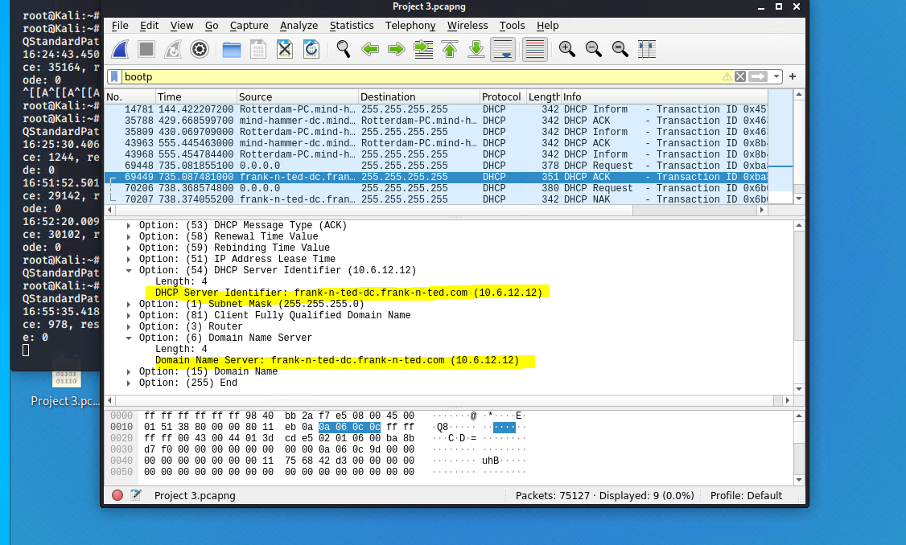

1. What is the name of the malware downloaded to the 10.6.12.203 machine? June11.dll
   * Once you have found the file, export it to your Kali machine's desktop.

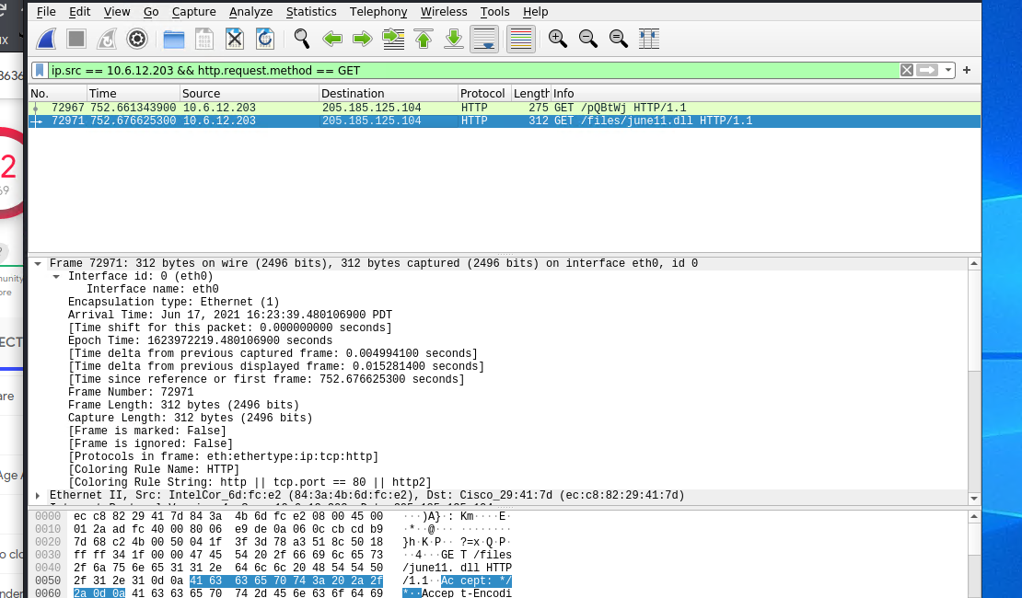

1. Upload the file to [VirusTotal.com](https://www.virustotal.com/gui/).
2. What kind of malware is this classified as? Classified as a Trojan

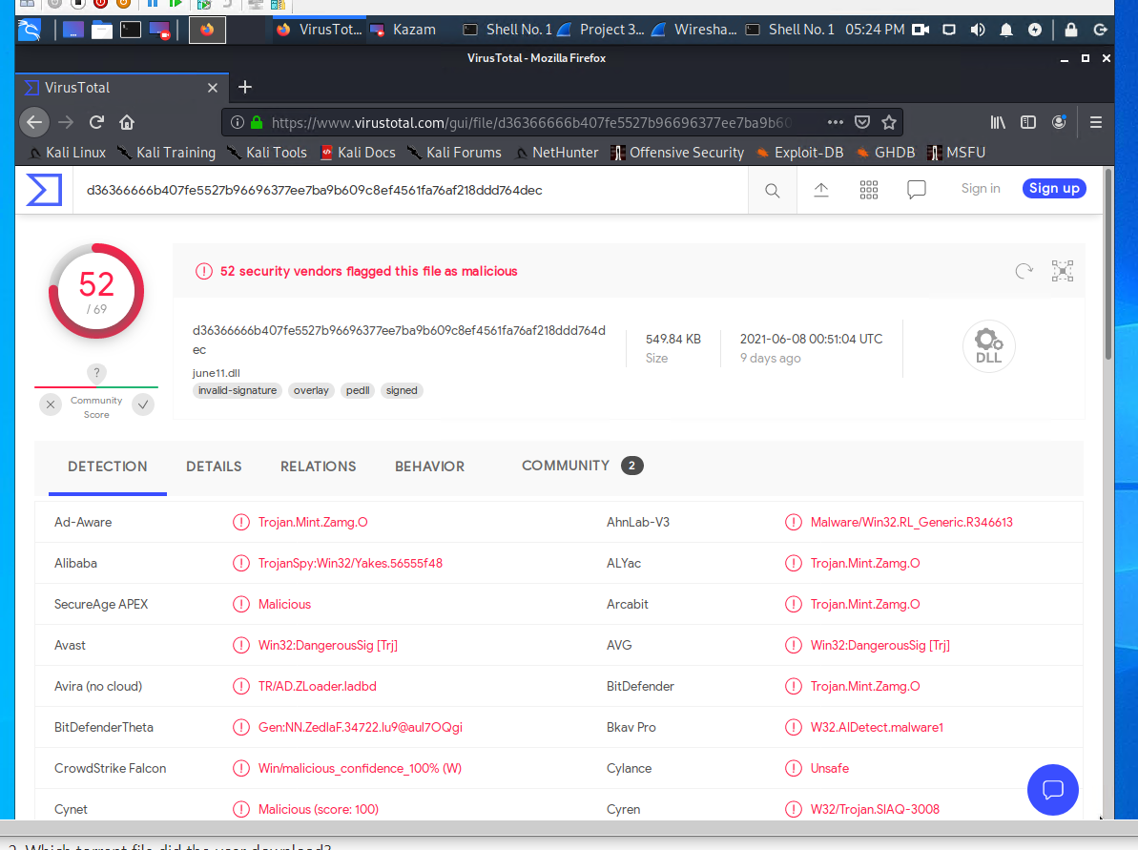

### Vulnerable Windows Machine

1. Find the following information about the infected Windows machine:
   * Host name- Rotterdam-PC.mind-hammer.net
   * IP address- 172.16.4.4
   * MAC address LenovoEM_b0:63:a4 (00:59:07:b0:63:a4)

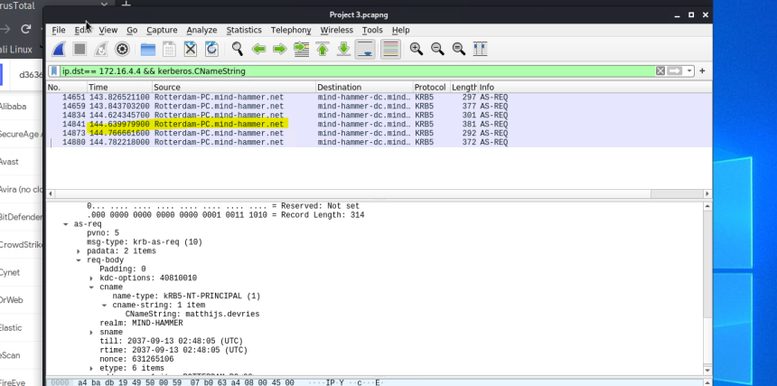

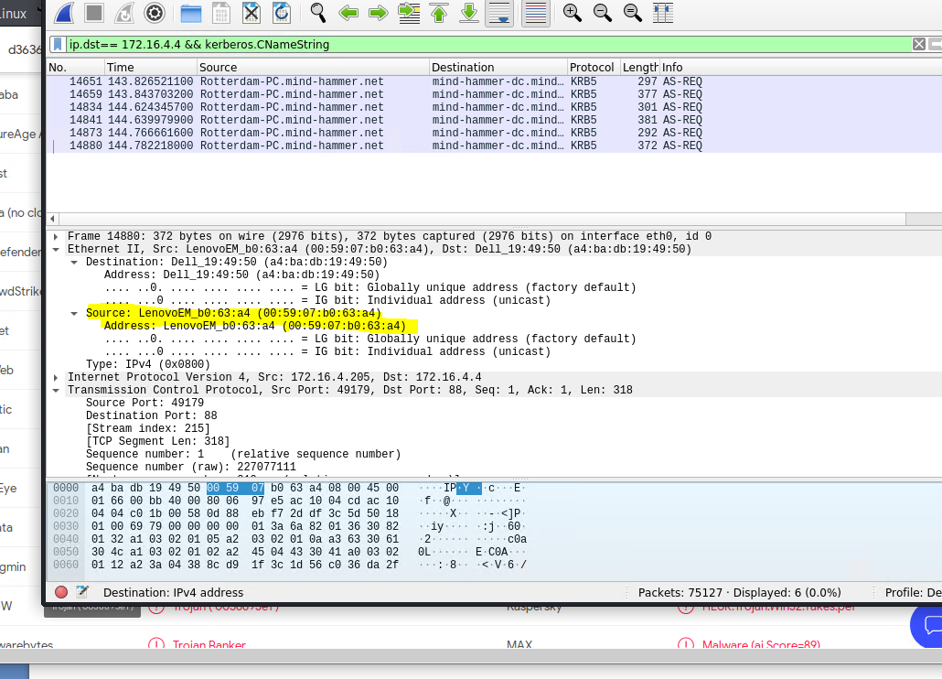

1. What is the username of the Windows user whose computer is infected? Matthijs.devris

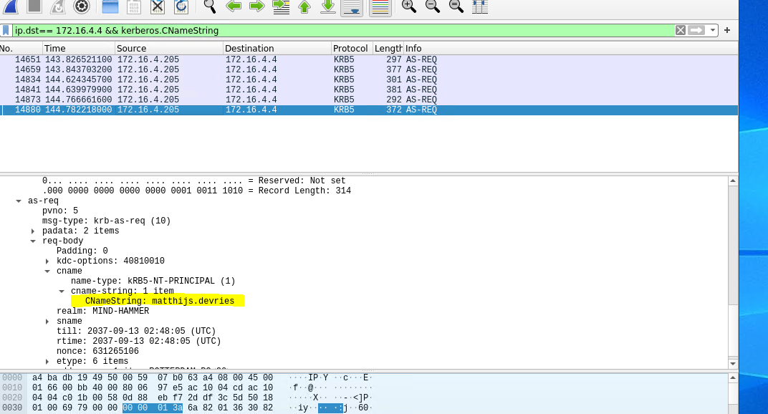

1. What are the IP addresses used in the actual infection traffic? 185.243.115.84

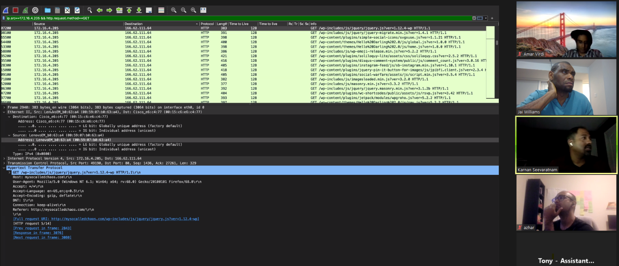

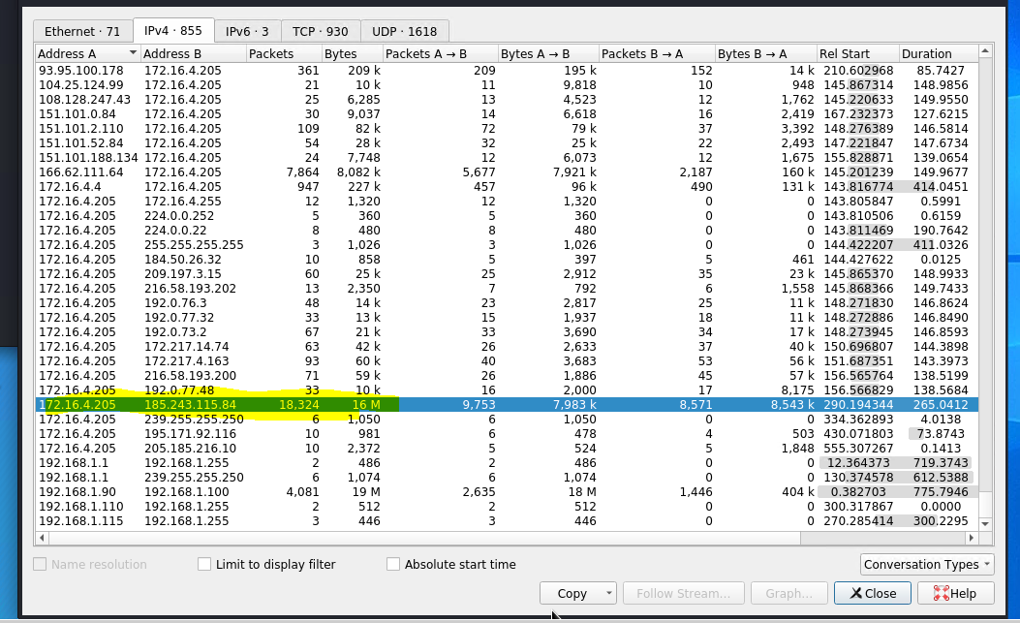

1. As a bonus, retrieve the desktop background of the Windows host.

### Illegal Downloads

1. Find the following information about the machine with IP address 10.0.0.201:
   * MAC address - Msi_18:66:c8 (00:16:17:18:66:c8)
   * Windows username- Mozilla /5.0
   * OS version -Windows NT 10.0

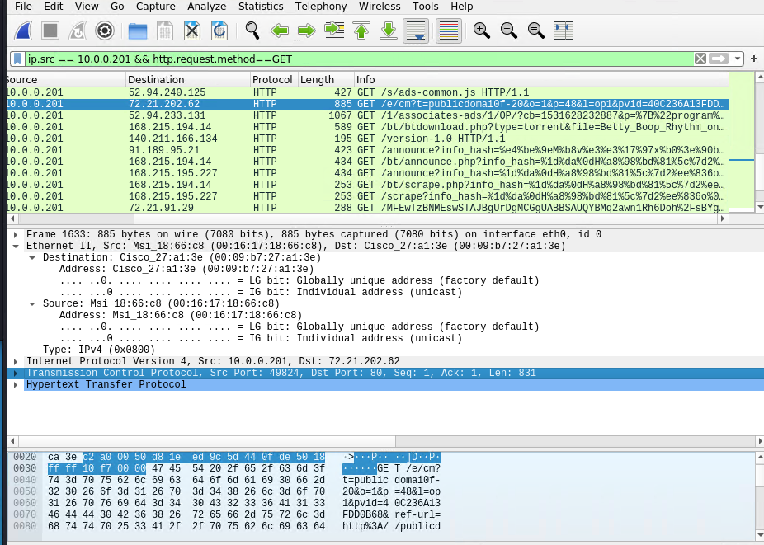

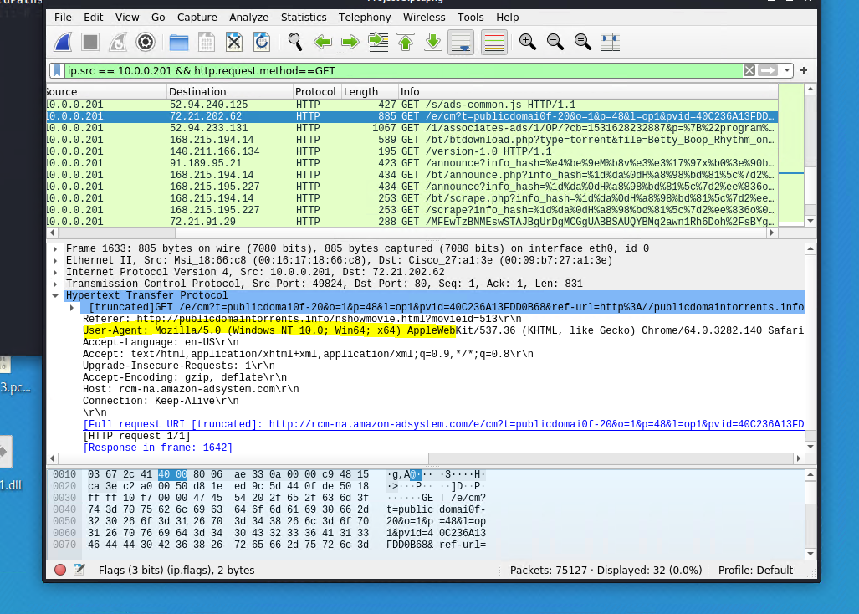

1. Which torrent file did the user download? Betty_Boop_Rhythm_on_the_Reservation.avi.torent

